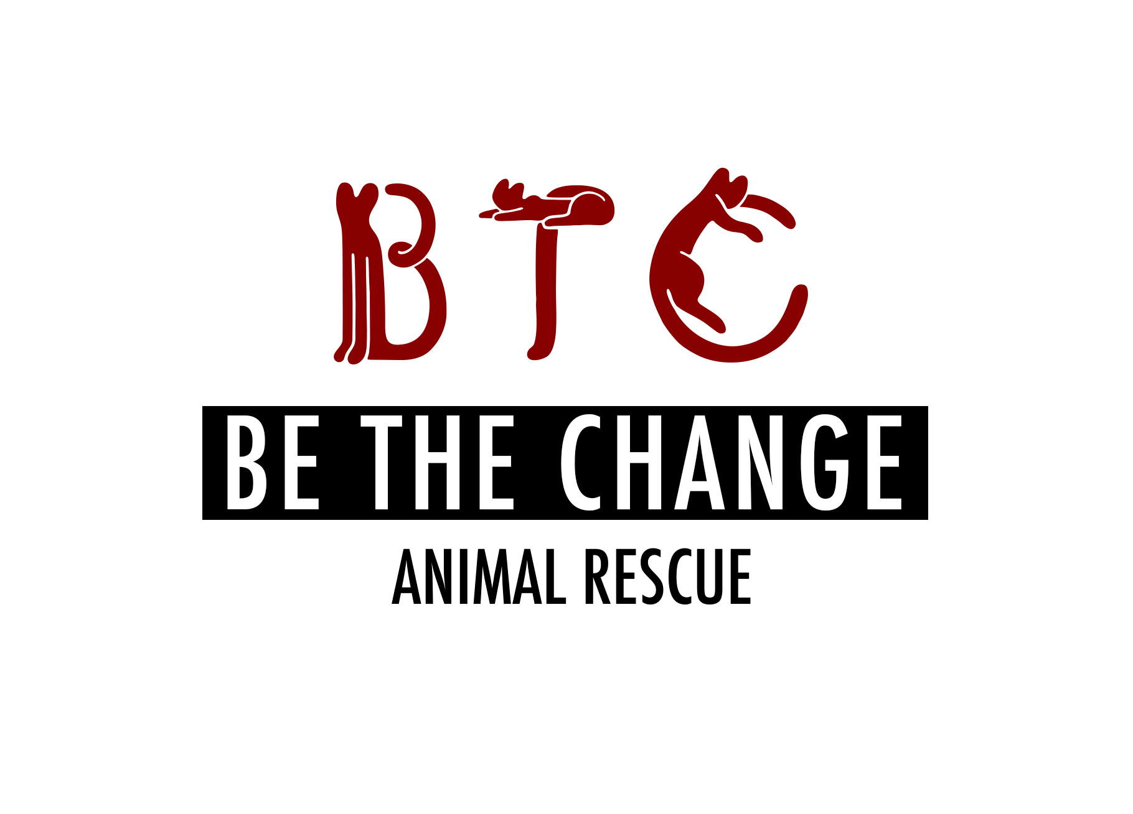
Be The Change Animal Rescue Application (BTCAR) For Cat Adoption

*If more than one person if primary caretaker, please give info for all
Applicant name (first and last):

Preferred pronouns (she/her, he/him, they/them):

Address:

City, State: ZIP:

Home phone/cell:

E-mail:

Employer:

Occupation:

Age:

Social media (please list all accounts)
FB:
IG:
LikedIn:

1. What type of cat are you interested in?

(Male/Female; Adult/Kitten (under 5 months); Long Hair/Short Hair)

Personality type:

Color (if applicable):

Or if you are interested in a specific cat, name of cat you are interested in?

2. Please list the first and last names of ALL the people who reside in your household and your relationship to each other.

3. Any children in the household? If so, please list ages:

4. For whom are you adopting the cat? (Self/Gift)

5. Does anyone in your household have any allergies to animals?

If yes, explain:

6. Who will be the primary caretaker for the cat(s)?

7. Where do you live? (Apartment/Condo/Farm/Mobile home/Townhouse/House)

8. Do you own or rent your residence? If you rent, what is name of landlord and phone number? How long have you lived there and do you plan to move?

9. Are companion animals allowed in your residence?

10. Where will the cat be kept? (Indoors only/Outdoors only/Both in/out)

11. If outdoors, will the cat be attended or unattended. What steps will you take to make sure the cat does not get away?

12. Do you currently have any of the following? Circle any that apply:

Porch / terrace or balcony / holes or cracks in your home (in the walls or flooring)/ fireplace/ window that does not have a screen / gas stove knobs /window a/c

*Adjustable window screens are NOT cat safe. If you do not have full custom window screens we can help you make the windows kitty safe with limiters and other materials. Are you willing to invest in making windows cat safe?

*Accordion screens on the side of window air conditioning units often need reinforcement as cats can easily push through. Are you willing to make appropriate enhancements if needed?

13. Will anyone be home during the day?

14. How many hours will the cat be left unattended on a typical day?

15. When no one is home, where will the cat be kept?

16. If you move, what will you do with the cat?

17. If the cat is not spayed/neutered when you adopt, do you agree to be responsible for ensuring this cat is spayed/neutered by the age of 6 months? (It’s rare for us to adopt cats that are not spayed/neutered, and we will let you know if they are not.)

18. If behavioral problems arise or the cat turns out to be unsuitable for you, do you agree to communicate the issues to BTCAR and return to BTCAR if necessary?

19. Do you currently have any companion animals (cats, dogs, birds, fish, reptiles)?

20. Please describe all the companion animals that the cat you adopt from us will be in contact with.

Pet name | Breed (cat, dog, fish, bird, reptile) | Age& Sex | Spayed/  Neutered? | Temperament (aggressive, shy, friendly, playful) | If cat, what is FeLV status?

21. Depending on the cat you foster/adopt from us, do you agree to work with us to integrate the new cat smoothly into your home? We typically recommend that adopters keep the new cat in a separate room (bathroom, bedroom) if they have other pets or if the adopted cat is timid for at least 2 days, but we might revise the recommendation depending on the pets’ personalities, living arrangements, etc.

22. Please describe all the companion animals you had had but no longer care for.

Pet name | Breed (cat, dog, fish, bird, reptile) | How long did you have the pet? | Spayed/  Neutered? | Why is the pet no longer in your care?

23. Have you ever adopted an animal from a rescue/animal control agency? If so, do you remember the name and contact information for the group?

24. Have you ever had an application rejected for adoption of an animal from a rescue/animal control facility? If yes, which one and could you please explain the circumstances?

25. Are you financially able and willing to provide annual checkups, vaccinations, and ANY medical care necessary? (Annual veterinary care is typically $200-$300, and medical emergencies can run $300-$1000, sometimes more.)

26. Are you planning on declawing the cat you adopt from us?

27. Are you familiar with your local animal control laws?

28. Do you agree to permit a visit to your home/farm by appointment?

29. Do you agree not to hold BTCAR responsible if the cat scratches or bites or otherwise harms a resident or guest in your home? (We work to connect foster homes with friendly, sweet kitties, but even the best of us can be cranky some days.)

30. Do you agree to pay the adoption fee? **We’ve had to increase our adoption fee because the ASPCA offers only limited free spay/neuter services for rescuers due to staff shortages since the start of the COVID pandemic. We frequently get cats vetted at clinics that charge rescuers $100 per cat (still a big discount compared with private vets that charge pet owners $500-$1,000 for spay/neuter). The fee is now $200 for 1 kitten or cat and $350 for a double adoption (2 kittens or 2 cats). In addition to spay/neuter, this fee helps cover the cost of rabies and FVRCP vaccinations, SNAP test (for FIV and FeLV), flea and parasite treatment, and microchipping.

31. Are you willing to sign legal pet adoption papers?

32. Why do you want to adopt a cat?

33. . Could you please provide the names and numbers or email addresses of three references? These could be friends, coworkers, or family that we could quickly touch base with as a background check. IF YOU HAVE/HAVE HAD A VETERINARIAN PLEASE PROVIDE THAT INFO AS A REFERENCE
If you live with other adults, please include their names.

Contact #1-VETERINARIAN if applicable

Contact #2-

Contact #3-

34. Do you have a back up person or plan for their animals in the event you become unable to care for them now or in the future?

35. By signing this form, I/we acknowledge that all information on this form is true and correct. I/we understand that any misrepresentation of fact may result in to BTCAR refusing foster/adoption privileges to me/us. If my/our request for foster/adoption is approved and later BTCAR discovers the above information is not true or correct, to BTCAR reserves the right to remove the foster/adopted cat from my home.

36. By signing this form I/we agree to the following:
While all adoptions are considered foster to adopt for the first month:
adoption fees are collected at the time we transfer the animal. This is considered a refundable deposit for the first 30 days. During this time either the rescue or the adoptee may decide it is not a good match and the animal will return to our care. During this initial month, we stay in close contact with the adopting family, assisting with integration and with regular agreed upon check-ins and updates on the welfare of all involved and reserve the right to remove the animal if heath or behavior are in decline. We will ALWAYS for the lifetime of the animals, take them back, the adoption is considered final after the first month trial period and contracts are signed.

Signature________________________Date_______________________________________

